**Field Service Kit for FLX Gear- Pumps**

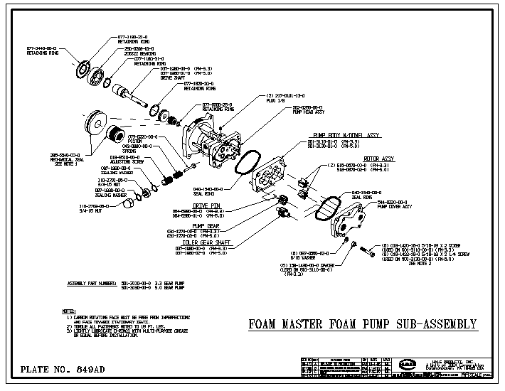

|  |  |  |  |  |
| --- | --- | --- | --- | --- |
| Model | Describtion | Part No. | Quantity | Remarks |
| All gear- pumps | O- Ring for Pump Body | 040-1540-00-0 | 2 | Grease before installation to keep in place |
| All gear- pumps | Mechanical Shaft- Seal | 296-5540-00-0 | 1 set | Clean running surfaces with alcohol tissue before installation, do not grease! |
| All | Feedback Sensor replacement kit | 546-3240-00-0 | 1 set includes seal- washer and O- Rings | Caution!  Installation Instructions must be exactly followed! Sensor must never block measuring gears from spinning. |
| All | Feedback Sensor only | 200-2481-00-0 | 1 | If seal- washer and O-Rings are re- usable |
| All gear- pumps | Pump- Shaft carbon- bearings | 250-9530-00-0 | 2 | Machine suitable pin to press in |
| All gear- pumps | Seal- Ring for relief- valve | 097-1980-00-0 | 2 |  |
| All | Motor Driver (Distribution Box) | 610-00044 | 1 | Must be specifically configured to match actual model. Field- procedure available but to be exactly followed. |
| All | Display head | 610-00028 | 1 | Hardware physically identical for all FLX. Software revision may need to be considered. Required Software version can be loaded at the factory. Use setup- procedure and recorded factors to avoid re- calibration |
| All | Injection Nozzle | 038-1790-00-0 | 1 | Service Item, do not glue in with Loctite |
| All | Paddlewheel Water Flow Sensor | 102714 | 1 |  |
| FLX 3.3 | Rotor Assy. (measuring gears) | 516-0670-00-0 | 1 set  (contains 2) | Check during installation, must spin absolutely free and easy |
| FLX 3.3 | Key for pump- gears | 064-6380-00-1 | 1 |  |
| FLX 3.3 | Upper pump- gear | 031-1270-00-0 | 1 |  |
| FLX 3.3 | Lower pump- gear | 037-1980-00-0 | 1 |  |
| FLX 5.0 and 6.5 | Rotor Assy. (measuring gears) | 516-0670-02-0 | 1 set  (contains 2) | Check during installation, must spin absolutely free and easy |
| FLX 5.0 and 6.5 | Key for pump- gears | 064-6380-01-1 | 1 |  |
| FLX 5.0 and 6.5 | Upper pump- gear | 031-1270-02-0 | 1 |  |
| FLX 5.0 and 6.5 | Lower pump- gear | 037-1980-02-0 | 1 |  |

The above parts shall allow the fix of most reported system- issues on- site. Refer to parts manual for any additional parts.

Parts listed under “All” may be used on any FLX System.

**Field Service Kit for FLX 1.7 and 2.1 Piston- Pumps**



|  |  |  |  |  |
| --- | --- | --- | --- | --- |
| Model | Describtion | Part No. | Quantity | Remarks |
| All | Seal- Washer for Feedback Sensor | 097-1971-00-0 | 1 | Fits any FLX |
| All | Feedback Sensor only | 200-2481-00-0 | 1 | Fits any FLX, except HP |
| All | Diode 42 V 240 A | 110589 | 1 | Fits any FLX |
| All | Motor Driver (Distribution Box) | 610-00044 | 1 | Must be specifically configured to match actual model. Field- procedure available but to be exactly followed. |
| All | Display head | 610-00028 | 1 | Hardware physically identical for all FLX. Software revision may need to be considered. Required Software version can be loaded at the factory. Use setup- procedure and recorded factors to avoid re- calibration |
| All | Injection Nozzle | 038-1790-00-0 | 1 | Service Item, do not glue in with permanent Loctite, fits any FLX |
| All | Paddlewheel Water Flow Sensor | 102714 | 1 | Fits any FLX |
| All | Side Mount Tank Level Sensor | 200-210-02-0 | 1 | Fits any FLX |
| All | Tank Select Plug | 513-0320-23-0 | 1 | Can be used to simulate Tank A selected and to check tank- selector- valves |
| FLX 1.7 and 2.1 | O- Ring for Rotor Housing | 040-0340-00-0 | 2 |  |
| FLX 1.7 and 2.1 | Flow- Meter Assy. | 115497 | 1 | Complete unit for total- exchange after fatal failure |
| FLX 1.7 and 2.1 | Rotor Assy. (measuring gears) | 016-1010-00-0 | 2 | Check during installation, must spin absolutely free and easy |
| FLX 1.7 and 2.1 | Pump Repair Kit A | 117495 | 1 | Plunger and seals |
| FLX 1.7 and 2.1 | Pump Repair Kit B | 117496 | 1 | Valves and seals |
| FLX 1.7 and 2.1 | Pump Repair Kit C | 117497 | 1 | Cam Bearing |

The above parts shall allow the fix of most reported system- issues on- site. Refer to parts manual for any additional parts.

Parts listed under “All” may be used on any FLX System

Fittings not listed here or in the parts- manual are common plumbing- parts, available from local hydraulic- parts suppliers.